MA Program in Psychology
Thesis Evaluation Form
Student Learning Outcome

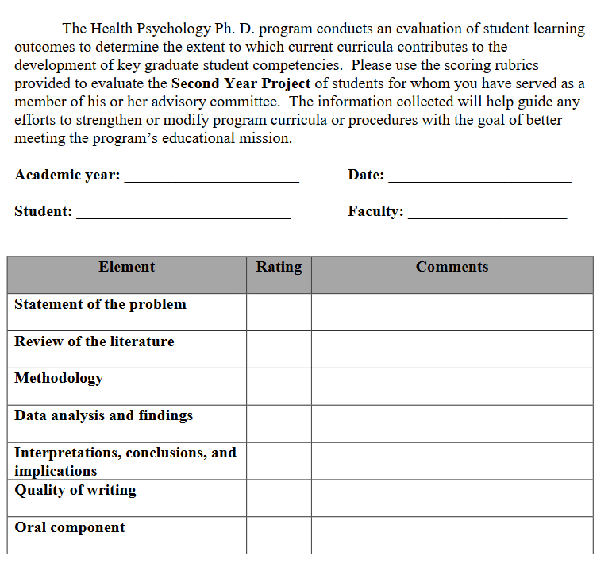

MA Program in Psychology
Thesis Evaluation Form
Student Learning Outcome Scoring Rubric

